Ideation Phase
Brainstorm & Idea Prioritization Template

Date | 8 September 2026
Team ID | SWUID2026190365
Project Name | ServiceNow-Based Employee Laptop Request Application
Maximum Marks | 4 Marks

Brainstorm & Idea Prioritization Template:
Brainstorming provides a free and open environment that encourages everyone within a team to participate in the creative thinking process that leads to problem solving. Prioritizing volume over value, out-of-the-box ideas are welcome and built upon, and all participants are encouraged to collaborate, helping each other develop a rich amount of creative solutions.
Use this template in your own brainstorming sessions so your team can unleash their imagination and start shaping concepts even if you're not sitting in the same room.
Reference: https://www.mural.co/templates/brainstorm-and-idea-prioritization
Step-1: Team Gathering, Collaboration and Select the Problem Statement


Step-2: Brainstorm, Idea Listing and Grouping


Step-3: Idea Prioritization
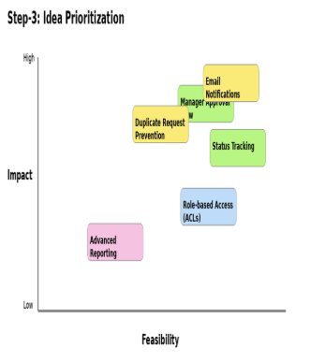

Ideation Phase
Define the Problem Statements

Date | 8 September 2026
Team ID | SWUID2026190365
Project Name | ServiceNow-Based Employee Laptop Request Application
Maximum Marks | 2 Marks

Customer Problem Statement Template:
Create a problem statement to understand your customer's point of view. The Customer Problem Statement template helps you focus on what matters to create experiences people will love.
A well-articulated customer problem statement allows you and your team to find the ideal solution for the challenges your customers face. Throughout the process, you’ll also be able to empathize with your customers, which helps you better understand how they perceive your product or service.
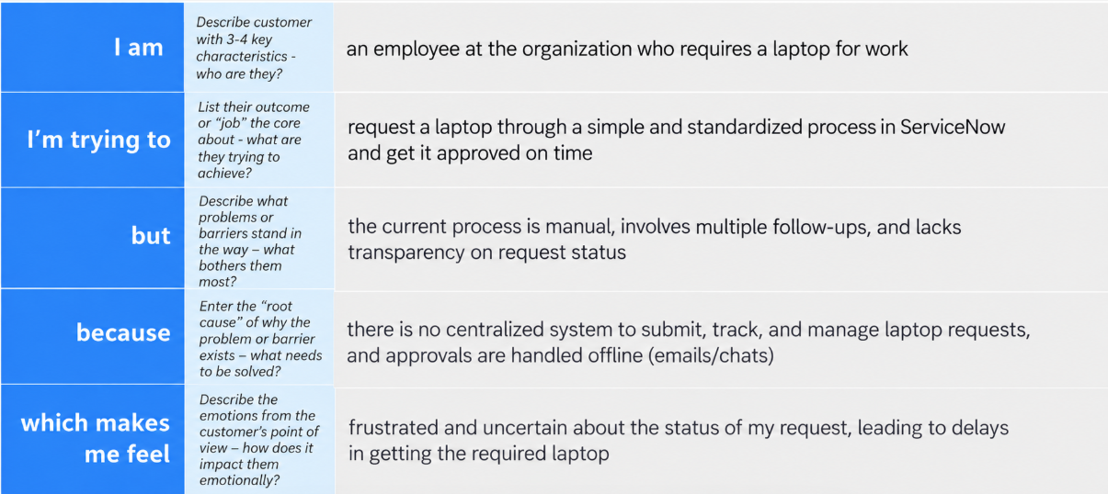
Reference: https://miro.com/templates/customer-problem-statement/
Example:
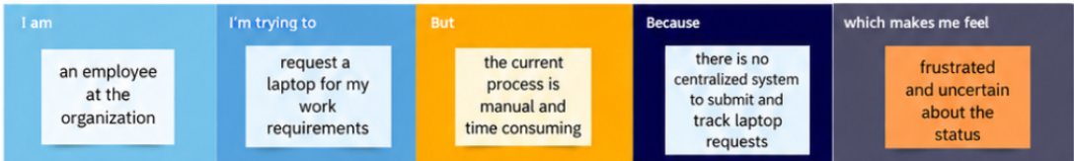

Problem Statement (PS) | I am (Customer) | I’m trying to | But | Because | Which makes me feel
PS-1 | Employee | submit a laptop request through a centralized system | the manual process can involve email or verbal requests and is difficult to track | there is no single automated request and approval process | frustrated and uncertain about the request status
PS-2 | IT Manager | review and approve employee laptop requests efficiently | requests may be difficult to track and duplicate requests can occur | there is no centralized automated approval and duplicate-prevention process | concerned about delays, duplicate requests, and accountability

Ideation Phase
Empathize & Discover

Date | 8 September 2026
Team ID | SWUID2026190365
Project Name | ServiceNow-Based Employee Laptop Request Application
Maximum Marks | 4 Marks

Empathy Map Canvas:
An empathy map is a simple, easy-to-digest visual that captures knowledge about a user’s behaviours and attitudes.

It is a useful tool to helps teams better understand their users.
Creating an effective solution requires understanding the true problem and the person who is experiencing it. The exercise of creating the map helps participants consider things from the user’s perspective along with his or her goals and challenges.
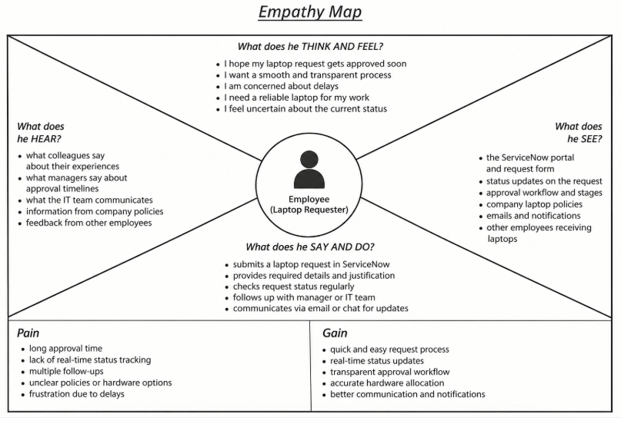
Reference: https://www.mural.co/templates/empathy-map-canvas

